Massage Intake Form

Personal Information
Name
Address

Phone (day) (evening)
City/State/Zip DOB

Occupation Employer
Email Primary Physician
Emergency Contact Relationship Phone
How did you hear about us?

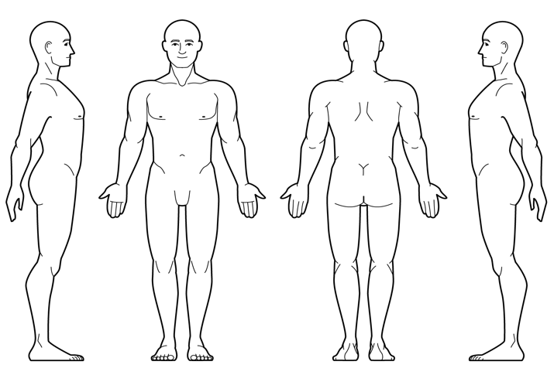
Medical Information Massage Information

Are you taking any medications? ☐ yes ☐ no
If yes, please list name and use: _ __ __ __ ______
______________________________________ __ ___ Are you currently pregnant? ☐ yes ☐ no
If yes, how far along? __ __ __ _____________ _
Any high risk factors? _ __ __ __ __ __ _______
Do you suffer from chronic pain? ☐ yes ☐ no
If yes, please explain __ __ __ __ __ ________
What makes it better? __ __ __ __ __ _______
__________________________________________ ___ What makes it worse? __ __ __ __ _ _______
______________________ __ __ __ __ __ ___ Have you had any orthopedic injuries? ☐ yes ☐ no
If yes, please list: __ _ __ __ __ __ _______
Please indicate any of the following that apply to you.
Have you had a professional massage before? ☐ yes ☐ no What type of massage are you seeking?
- Relaxation ☐ Therapeutic/Deep Tissue Other ___ __ _ __ __ __ __ __ ___________
What pressure do you prefer?
- Light ☐ Medium ☐ Deep
Do you have any allergies or sensitivities? ☐ yes ☐ no Please explain __ __ __ __ __ __ ________
Are there any areas (feet, face, abdomen, etc.) you do not want massaged? ☐ yes ☐ no
Please explain __ __ __ __ __ __ _____
What are your goals for this treatment session?
__ __ __ __ __ __ __ __ ___________ Please circle any areas of discomfort

- Cancer
- Headaches/Migraines
- Arthritis
- Diabetes
- Joint Replacement(s)
- High/Low Blood Pressure
- Neuropathy
- Fibromyalgia
- Stroke
- Heart Attack
- Kidney Dysfunction
- Blood Clots
- Numbness
- Sprains or Strains

By signing below, you agree to the following.

Explain any conditions you have marked above:
__ __ __ __ __ __ __ __ __ __ __ __
__ __ __ __ __ __ __ __ __ __ __ __
__ __ __ __ __ __ __ __ __ __ __ __
__ __ __ __ __ __ __ __ __ __ __ __
I have completed this form to the best of my ability and knowledge and agree to inform my therapist if any of the above information changes at any time.

Client Signature _ __ __ _______________ Date _____ ___

Therapist Signature ___ _ __ __ __ ___ Date __________

